**SETTING UP APPLICATION ENVIRONMENT**

**CREATE FLASK PROJECT**

Six Steps have been followed to create Flask Project.

The Steps that we have followed have been described below

**Step 1.** Install Python latest version from python.org

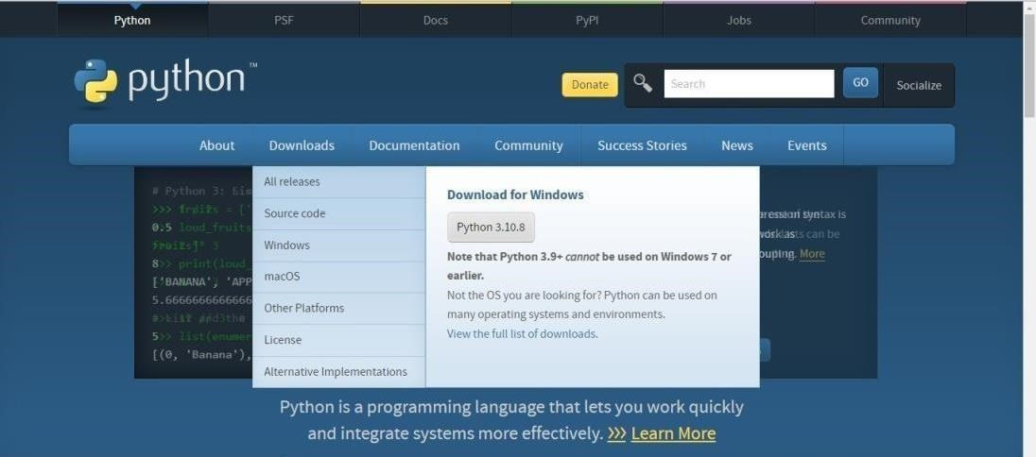

**Step 2**. Download Anaconda from https://[www.anaconda.com/](http://www.anaconda.com/) and install it byrunning the .exe file

**Step 3**.Install Flask using command pip install flask

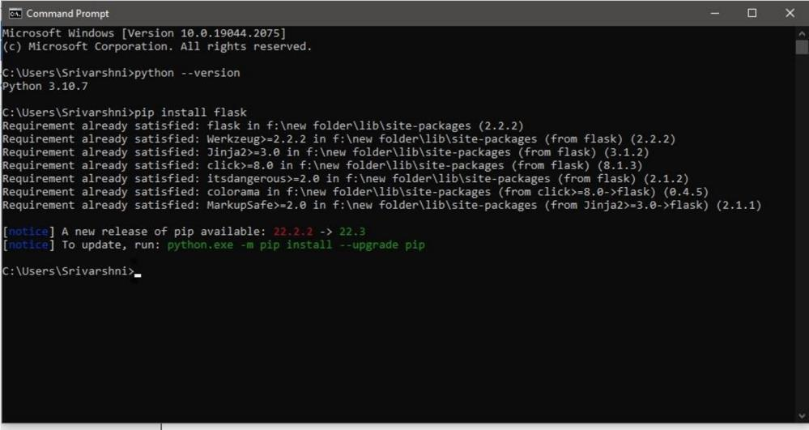

**Step 4**.Open a new Python file and start coding

from flask import Flask

app = Flask(



name )

@app.route('/') def hello():

return “Hello World” if name == ' main

':

app.run(debug=True)

**Step 5**. Run the Python file using command python filename.py

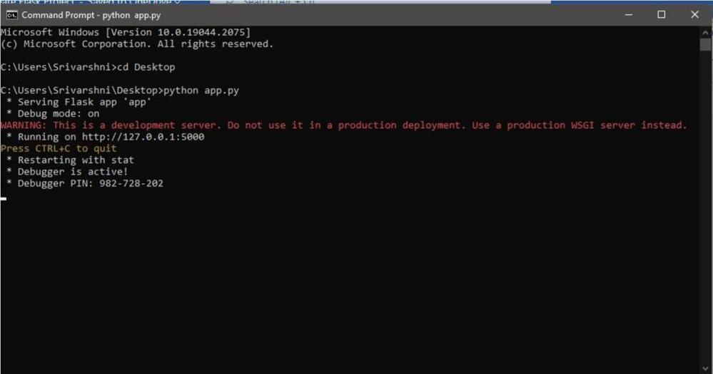

**Step 6**: Open the Ip in browser

